Monday | Tuesday | Wednesday | Thursday | Friday
 |  |  | 1 | 2  Early Release  GA PreK 1: 11:45  GA PreK 2: 12:00
5 | 6  National Read a Book Day | 7 | 8 | 9  Grandparents Day Tea 2:30  Book Fair Begins
12  Patriot Day  Wear Red, White and Blue to school  In and Out  Fall Pictures | 13  In and Out  Fall Pictures | 14 | 15  Make a Hat Day | 16  Book Fair Ends
19 | 20 | 21 | 22 | 23
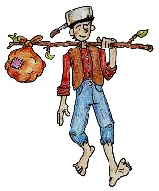  26  Johnny Appleseed Day: Dress Like Johnny Appleseed  No School Foco/GAPreK  Fall Break | 27  No School Foco/GAPreK  Fall Break | 28  No School Foco/GAPreK  Fall Break | 29  No School Foco/GAPreK  Fall Break | 30  No School Foco/GAPreK  Fall Break
