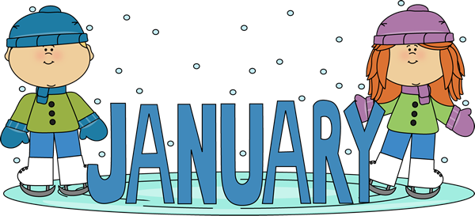

Monday | Tuesday | Wednesday | Thursday | Friday | Saturday/  Sunday
1  CARRINGTON  CLOSED | 2  CARRINGTON  CLOSED | 3  FOCO/GA-Pre-k  Student Holiday | 4  FOCO/GA-Pre-k  Student Holiday | 5  FOCO/GA-Pre-k  Student Holiday | 6/7
8  Bubble  Day | 9  Pre-K Field Trip to Petsmart | 10 | 11  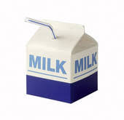  National Milk Day | 12 | 13/14  Rubber Ducky  Day
15  Martin Luther King Jr. Day  CARRINGTON CLOSED  Teacher Work Day | 16  January  Fundraiser  Starts  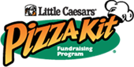 | 17  Kindergarten Field Trip to Towne Club Windermere-  Reading Buddies | 18 | 19  National Popcorn Day! | 20/21
22  SOUP-er Bowl Begins! | 23 | 24 | 25 | 26 | 27/28  National Chocolate Cake  Day
29  January  Fundraiser  Ends | 30 | 31  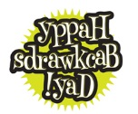  Let’s be silly as we wear our clothes, jackets, and hats BACKWARDS!

