2019-2020 Carrington Academy Big Creek School Calendar
August 2019  August 1st – Georgia Pre K 1st Day of School  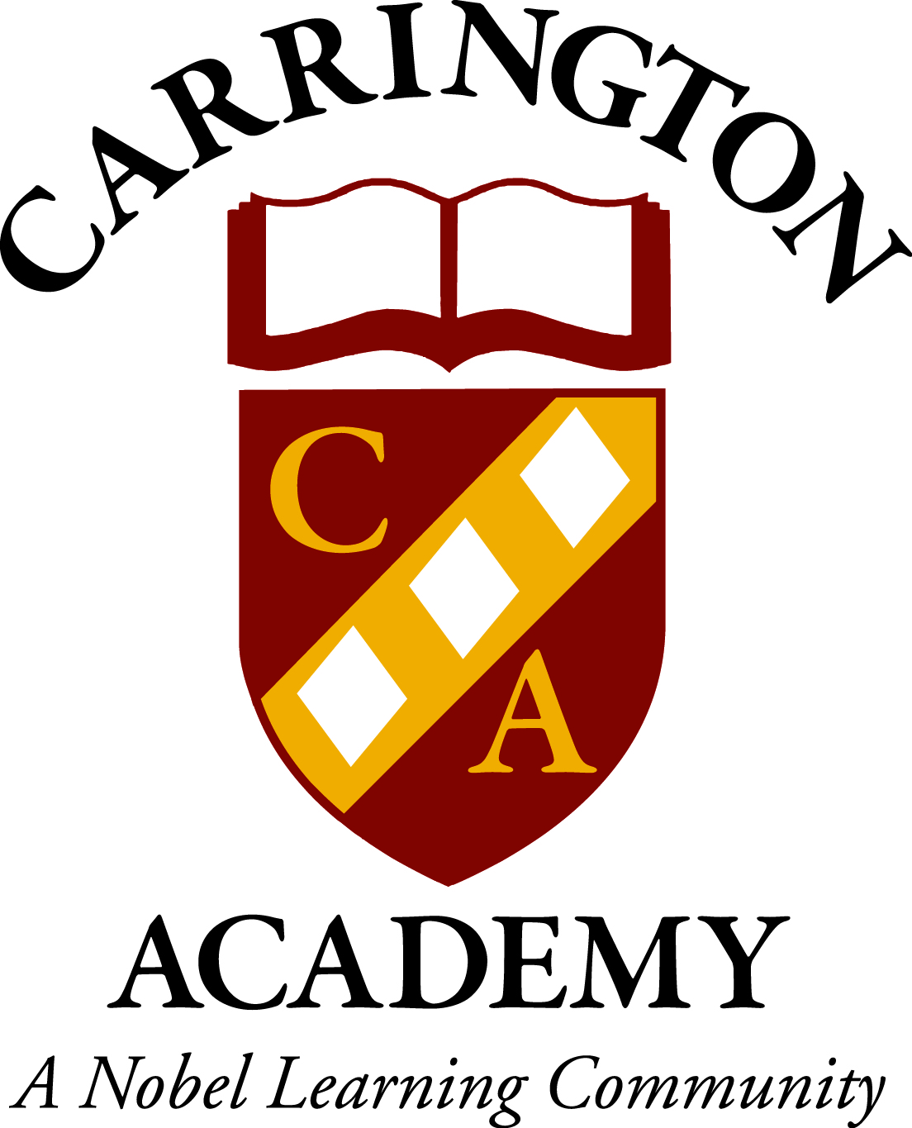  August 28th – Spoiled Rotten Fall Pictures *Sign up ONLY  August 30th – Georgia Pre K EARLY RELEASE @ 11:50 | January 2020  January 1st - CARRINGTON ACADEMY CLOSED  January 1st – 6th - GEORGIA PRE K – NO SCHOOL  January 13th – 17th - Private Parent Teacher Conferences  January 20th –GA PRE-K & FORYSTH COUNTY-NO SCHOOL  January 15th – In & Out Valentines Pictures (Black and white)
September 2019  September 2nd – CARRINGTON ACADEMY CLOSED  September 6th – Grandparents Day Celebration  Toddler, Beginner 1 & Beginner 2 – 2:30pm  Intermediates – 3:00pm  Private Pre K & Pre K 2 – 2:00pm  Georgia One – 9:45am  September 20^{th-} In & Out Fall Pictures (School Wide)  September 30th – GEORGIA PRE K – NO SCHOOL  September 30th – Fall Break Camp Available | February 2020  February 3rd-13th – Valentine’s Day Fundraising  February 7th – National Wear Red Day (Heart Awareness)  February 14th – Fundraiser Celebration  February 14th – Valentines Exchange & Parties  Toddler, Beginner 1 & Beginner 2 – 3:00pm  Intermediate 1 & Intermediate 2 – 3:30pm  Private Pre K & Pre K 2 – 4:00pm February 14th – 18th - GEORGIA PRE K – NO SCHOOL  February 20th – In & Out Spring/ Graduation Pictures
October 2019  October 1st – Pink Out  October 1st – 3rd – Fall Break Camp Available  October 1st – 4th – GEORGIA PRE K – NO SCHOOL  October 4th – CARRINGTON ACADEMY CLOSED  October 11th – Parent Appreciation Breakfast 7am-9am  October 14th – 18th – Private Parent Teacher Conferences  October 18th – Fall Festival & Trunk or Treating 5-7  October 23rd – Life Touch Fall Pictures (School Wide)  October 31st – Halloween Parties & Pajamas  Toddler, Beginner 1 & Beginner 2 – 3:00pm  Intermediate 1 & Intermediate 2 – 3:30pm  Private Pre K & Pre K 2 – 4:00pm  Georgia One – 9:45am | March 2020  March 6th – Parent Appreciation Breakfast 7:00am-9:00am  March 5th & 6th – Life Touch Spring Pictures (School Wide)  March 12th & 13th - Georgia Pre K EARLY RELEASE @ 11:50  March 13th – CARRINGTON ACADEMY CLOSED  March 17th – St. Patrick’s Day Classroom Activities  March 23rd-31st- Easter Egg Donations
November 2019  November 1st – 21st – Canned Food Drive  November 5th – In & Out Santa Pictures (School Wide)  November 5th – 9th – Fall Book Fair  November 15th – Thanksgiving Feast (Sign Up Only)  November 25th -29th - GEORGIA PRE K – NO SCHOOL  November 25th -27th - Thanksgiving Camp Available  November 28th & 29th - CARRINGTON ACADEMY CLOSED | April 2020  April 1st – 8th – Easter Egg Donations  April 6th-10th - GEORGIA PRE K – NO SCHOOL (spring break)  April 6th-10th – Spring Break Camp Available  April 10th – Annual Easter Egg Hunt  April 13th – 17th – Week of The Young Child  April 13th – 17th – Spring Book Fair  April 20th – 24th - Private Parent Teacher Conferences  April 22nd – Earth Day Celebrations
December 2019  December 3rd – 14th – Holiday Gram Available for purchase  December 17th – 20th – Georgia Pre K Conferences  December 20th – Polar Express Day  December 20th – Georgia Pre K Holiday Parties  December 20th – Holiday Traditions Parties  Toddler, Beginner 1 & Beginner 2 – 3:00pm  Intermediate 1 & Intermediate 2 – 3:30pm  Private Pre K & TK – 4:00pm  December 23rd – 31st - GEORGIA PRE K – NO SCHOOL  December 24th & 25th - CARRINGTON ACADEMY CLOSED  December 31st – CARRINGTON ACADEMY CLOSED | May 2020  May 4th – 8th – Teacher Appreciation Week  May 8th – Mother’s Day Celebration – 7:00am-9:00am  May 13th-17th - Georgia Pre K Conferences  May 20th – Pre K & Pre-K 2 Program Graduation 4:00 PM- 5:00 PM  May 22nd – Georgia Pre K End of Year Parties  May 22nd – Last Day of School  May 25th – CARRINGTON ACADEMY CLOSED  May 26th – Summer Camp Begins

