2019-2020 Carrington Academy MAJORS School Calendar
August 2019  July 29nd – 1st day of Private Classes  July 31st – Georgia Pre-K Open House  August 1st – Georgia Pre K 1st Day of School  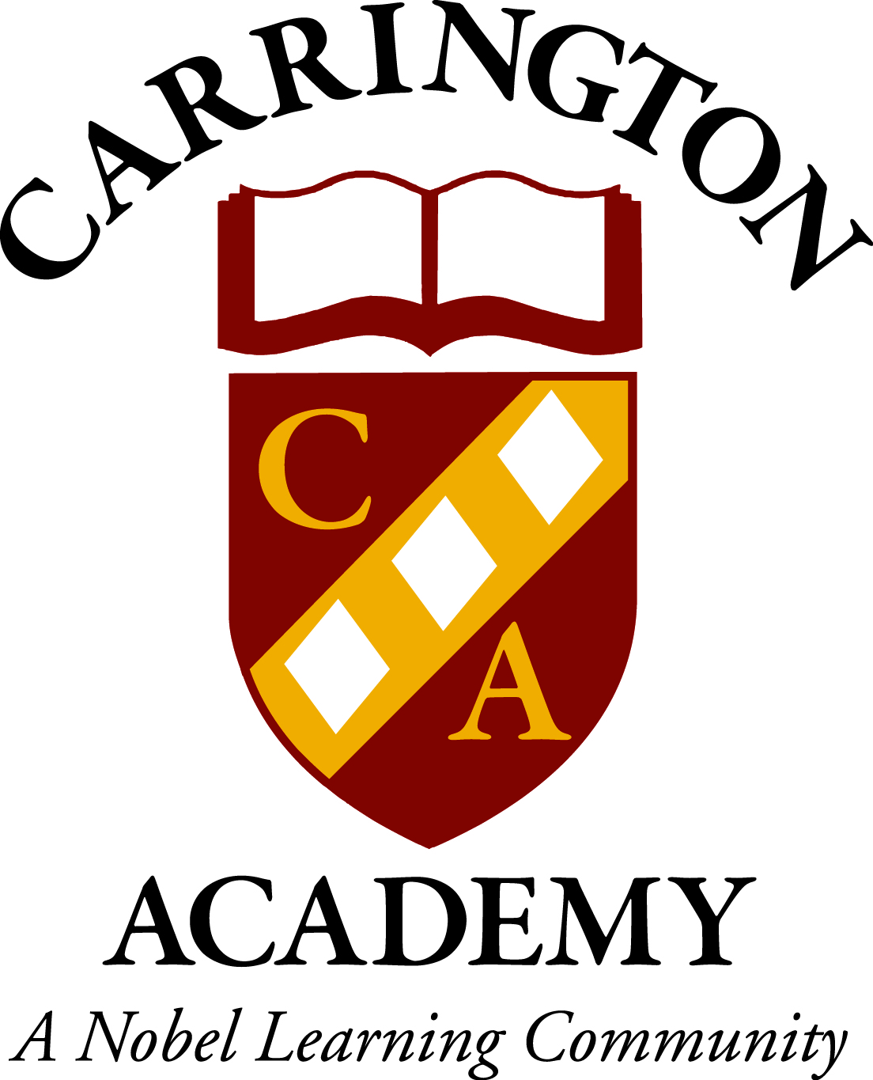  August 27th – Spoiled Rotten Fall Pictures *Sign up ONLY  August 30th – Georgia Pre K EARLY RELEASE @ 11:50 | January 2020  January 1st - CARRINGTON ACADEMY CLOSED  January 1st – 6th - GEORGIA PRE K – NO SCHOOL (camp available)  January 13th – 17th - Private Parent Teacher Conferences  January 16th-17th – In & Out Valentines Photos (black & white)
September 2019  September 2nd – CARRINGTON ACADEMY CLOSED – Labor Day  September 6th – Grandparents Day Celebration – times for event will be announced closer to date  September 10^{th-} & 11th – In & Out Fall Pictures (School Wide)  September 30th – GEORGIA PRE K – NO SCHOOL  September 30th – Fall Break Camp Available | February 2020  February 3rd-13th – Valentine’s Day Fundraising  February 7th – National Wear Red Day (Heart Awareness)  February 13th – Georgia Pre-K Valentines Exchange – party times to be announced closer to date  February 14th – Valentines Exchange Private classes– All party times will be announced closer to date  February 14th – 18th - GEORGIA PRE K – NO SCHOOL –  (camp available)  February 20th – In & Out Spring/ Graduation Pictures
October 2019  October 1st – Pink Out  October 1st – 3rd – Fall Break Camp Available  October 1st – 4th – GEORGIA PRE K – NO SCHOOL  October 4th – CARRINGTON ACADEMY CLOSED – professional development day  October 10th & 11th– Lifetouch Fall Pictures  October 14th – 18th – Private Parent Teacher Conferences  October 18th – Fall Festival & Trunk or Treating 6-8pm  October 23rd & 24th – Georgia Pre-K Early Release  October 25th – Georgia Pre-K – NO SCHOOL  October 25th – Parent Appreciation Breakfast 7am-9am  October 31st – Halloween Parties & Pajamas - All party times will be announced closer to date | March 2020  March 6th – Parent Appreciation Breakfast 7:00am-9:00am  March 12th - Georgia Pre K EARLY RELEASE @ 11:45  March 13th – CARRINGTON ACADEMY CLOSED – professional development day  March 17th – St. Patrick’s Day Classroom Activities  March 23rd-31st- Easter Egg Donations
November 2019  November 1st – 21st – Canned Food Drive  November 6th – In & Out Santa Pictures (School Wide)  November 15th – Thanksgiving Feast (Sign Up Only)  November 25th -29th - GEORGIA PRE K – NO SCHOOL  November 25th -27th - Thanksgiving Camp Available  November 28th & 29th - CARRINGTON ACADEMY CLOSED | April 2020  April 1st – 8th – Easter Egg Donations  April 6th-10th - GEORGIA PRE K – NO SCHOOL (spring break)  April 6th-10th – Spring Break Camp Available  April 10th – Easter Egg Hunt for Private Classes - times TBD  April 13th – Easter Egg Hunt for Georgia Pre- K – times TBD  April 13th – 17th – Week of The Young Child  April 20th – 24th - Private Parent Teacher Conferences  April 22nd – Earth Day Celebrations
December 2019  December 2019 - Georgia Pre K Conferences - TBD  December 3rd – 14th – Holiday Gram Available for purchase  December 19th – Polar Express Day  December 19th – Georgia Pre K Holiday Party – All party times to be announced closer to date  December 20th – Holiday Traditions Parties – All party times to be announced closer to date  December 20th – 31st - GEORGIA PRE K – NO SCHOOL  December 24th & 25th - CARRINGTON ACADEMY CLOSED  December 31st – CARRINGTON ACADEMY CLOSED | May 2020  May - Georgia Pre K Conferences - TBD  May 4th – 8th – Teacher Appreciation Week  May 8th – Mother’s Day Celebration – 7:00am-9:00am  May 20th – Private Pre-K & TK Program Graduation 6:30-8pm  May 22nd – Georgia Pre K End of Year Parties - Times will be determined closer to date  May 22nd – Last Day of School  May 25th – CARRINGTON ACADEMY CLOSED - Memorial Day  May 26th – Summer Camp Begins

