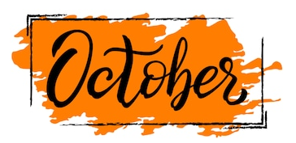
Monday | Tuesday | Wednesday | Thursday | Friday
 |  |  | 1 | 2
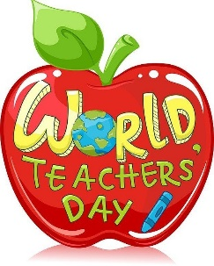  5 | 6  National Fire Safety Week  We will be participating in fire safety activities thought the week. | 7  Read about firefighters and discuss the importance of fire safety rules with kids. | 8  Practice a fire drill at home and set a safe meeting spot!  Please e-mail pictures to tiffany.batts@carringtonacademy.com  Home connection | 9
12  Private Programs:  VIRTUAL Parent-Teacher Conferences | 13  Intermediates Zoom Conferences  (9:30-11:30) | 14  Private Pre-K Zoom Conferences  (9:30-11:30) | 15  Must sign up in advance please | 16  Enjoy doing pumpkin yoga.
19  Accepting “nut free” candy donations  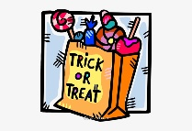 | 20  Go on a nature walk and count how many pumpkins you see on your neighbors’ porches.  Home connection | 21  Lifetime Pictures  must email tiffany.batts@carringtonacademy  IF YOU DO NOT WANT PICTURES | 22  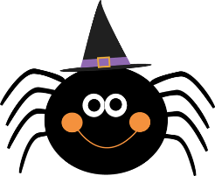 | 23  GA Pre-K Early Release  Private Program  Carrington Closed
26  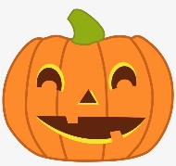  Bring a pumpkin to decorate. We will be accepting “nut free” candy donations. | 27  Wear two different socks to school and show your friends your silly feet. | 28  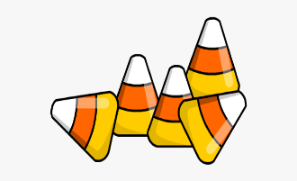  National Candy corn Day! | 29  Wear your favorite Halloween shirt or favorite Fall color shirt to school. | 30  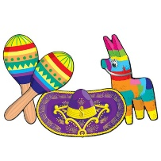  Fiesta Friday!!  Wear colorful attire!

