Monday | Tuesday | Wednesday | Thursday | Friday
COLLECTION BEGIN FOR SANTA’S ANIMALS… (benefiting)  Forsyth County Humane Society- | 1  PENGUIN GRAMS BEGIN  ($5 ea) | 2 | 3 | 4
7  Fun Holiday  T-shirt Day!  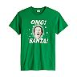 | 8  ELF DAY!! | 9  POLAR BEAR DAY!! | 10  CANDY CANE DAY!! | 11  REINDEER DAY!!!
14  Snowman Day | 15  Flannel Day | 16  SANTA DAY!! | 17  Holiday Sock Day | 18  Tacky Sweater Day  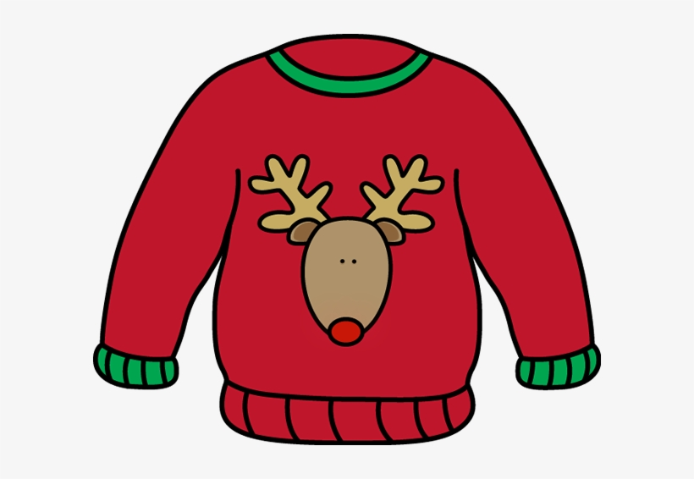  Humane Society collection ends
21  CHEF CHRIS AND HOLIDAY COOKIES WITH MILK!!  1st Day of Winter | 22  GA PK party!!  LAST DAY OF SCHOOL!  SEE YOU BACK ON 1.6.21 | 23  Private class parties  Camp Available! | 24  SCHOOL CLOSED | 25  SCHOOL  CLOSED
28  No GA PreK  Winter Camp Available! | 29  No GA PreK  Winter Camp Available! | 30  No GA PreK  Winter Camp Available! | 31  School CLOSED | 1  School CLOSED

