How Our Preschool Prepares Children for the Future
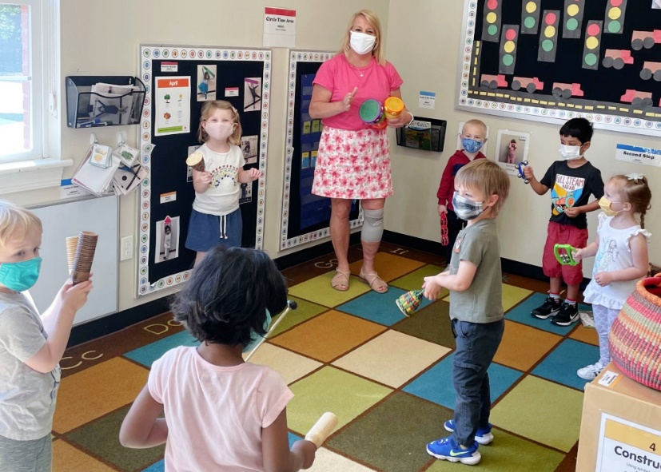
Preschool is the first introduction to a lifetime of learning, a journey that should start off on the right foot. Children learn numbers, letters, shapes and colors, but also the important social and emotional skills needed for success in kindergarten and beyond.
Our school combines learning experiences and structured play in a safe and nurturing environment. Our entire focus is making sure children are happy, thriving and ready for what comes next. We offer far more than just child care.
Below are a few reasons why preschool is so important and why our school is the perfect choice.
Preschool Builds Foundational Academic Skills
It’s never too early to introduce children to basic literacy and math skills. Our proprietary Links to Learning curriculum begins with our infants and is organized into five developmental stages incorporating eight subject areas. It is robust, yet flexible, empowering our teachers to meet the needs of each child. Our students have constant access to books, encouraging them to explore printed text and make connections between printed words and illustrations. Hands-on experiences with basic math concepts help children learn the foundation of addition, subtraction, and different ways to compare quantities.
Preschool Helps Develop Social-Emotional Skills
The preschool years are a crucial time for children to interact with peers, learn how to share, resolve conflicts, talk about their feelings and develop empathy for others. Each day, our students engage in hands-on activities in our fun and stimulating learning centers. Whether building a tower in the construction center, playing make-believe with friends in the dramatic play center or conducting an experiment in the science center, they have fun developing social-emotional skills as they move throughout the classroom.
Preschool Fosters Creativity and Curiosity
Young children have active imaginations and are naturally curious about the world around them. Our classrooms are warm, nurturing environments designed to support learning and encourage curiosity. Through music, art and imaginative play, our students learn self-expression and creative thinking. During circle time, a classroom community is built as students share opinions and ask questions.

