Monday | Tuesday | Wednesday | Thursday | Friday
 |  |  |  | 1
4  Week of the Young Child: Music Monday  Spring Break Forsyth County/GA Pre-k | 5  Week of the Young Child: Tasty Tuesday  Spring Break Forsyth County/GA Pre-k | 6  Week of the Young Child: Work Together Wednesday  Spring Break Forsyth County/GA Pre-k | 7  Week of the Young Child: Artsy Thursday  Spring Break Forsyth County/GA Pre-k | 8  Week of the Young Child: Family Friday  Spring Break Forsyth County/GA Pre-k
11 | 12  Grilled Cheese Sandwich Day | 13 | 14 | 15  Class Easter Parties and Egg Hunt
18 | 19 | 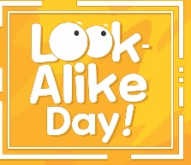  20  Dress Like a friend | 21 | 22  Ladybug Release
25 | 26 | 27 | 28  Dress Like your favorite superhero | 29

