Summer is here and we are teaching, learning, and growing together! Our students are jumping into action, playing games, exploring nature, being creative, and participating in other fun summer-themed activities. We can’t wait to see what the rest of the summer holds for us.
Sincerely,
Jenna Poss

Independence Day Activities
Our classrooms will be working on festive activities for July 4th all week long. Let’s wear our red, white, and blue on July 5, 2022, in honor of Independence Day! Please also remember that ALL Carrington Academy locations will be closed on Monday July 4th.

Kids Helping Communities
Each summer, we participate in a service initiative to give back to communities in need. This summer, we will be collecting monetary donations for Alex’s Lemonade Stand. We are participating in this fundraiser to help Alex’s Lemonade Stand Foundation move one step closer to finding a cure for all children with cancer. Donations can be made directly to our event page as well as in person when our Summer Camp students set up and run a Lemonade stand during afternoon pickup. The money you donate will pay for research to find better treatments and cures for childhood cancer. Please help kids and their families by providing desperately needed hope! Thanks for your support! We will be sending additional information soon via Links 2 Home.

Cubby Refresh
As a reminder, please make sure to refresh the spare clothing in your child’s cubby. Take home anything that no longer fits and leave a spare set of well-fitting, weather-appropriate clothes.

Important Dates
July 4th - School closed
July 25th - Kids Helping Communities donation drive
July 29th - End of Month Folders go home (last day of the school year)

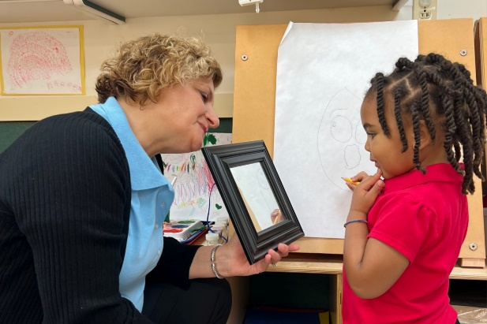
What Diversity, Inclusion, and Belonging Looks Like in Our Classrooms
Children learn best, develop self-confidence, and thrive when they feel valued and supported. Because of this, diversity, inclusion, and belonging are hallmarks of our school community. Our teachers strive to cultivate learning environments that foster respect and acceptance and encourage students to learn from and with each other.
Our classrooms contain a range of materials to provoke children’s questions, ideas, and attitudes about their own identities and about differences and similarities among others. Items in our classrooms highlight each student's culture in a positive way and include rich literature that holistically reflect the students in the classroom community and showcase diverse family structures, dolls with various skin tones, a variety of art and musical instruments from other countries, music in multiple genres and languages, and culturally diverse dramatic play props.

