Monday | Tuesday | Wednesday | Thursday | Friday
 |  |  |  | 1.  
4  Teacher Questionaire and cards | Teacher Breakfast *Sign up Genius* | 6  Surprises for your Teacher! | 7  Stuff the Tote Bag! | 8    Mother’s Day Breakfast 7:30-9am
  11  Beginners - PPK | 12  Be sure to sign  Up on your classroom door  For a conference! | 13  Wear it Wednesday!    Cheetah Print! | 14    National Dance like a Chicken Day! | 15  GA & Private PreK  Family Picnic  11am-1pm
18  Spirit Week –  Hat Day   | 19  Spirit Week –      Superhero/Princess Day  This Photo by Unknown Author is licensed under CC BY-SA | 20    Spirit Week –  Pajama Day  Parent Appreciation  Grab & Go Breakfast | 21  Spirit Week –  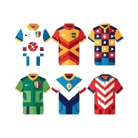  Jersey Day  Last day of GA PreK | 22  Spirit Week –  Class Colors    End of Year Class Parties (Times TBA)
  25  School CLOSED for Memorial Day | 26    1st Day of Summer Camp | 27  Wear it Wednesday    Tropical Print | 28  National Hamburger Day!!   | 29    Cookie Friday!
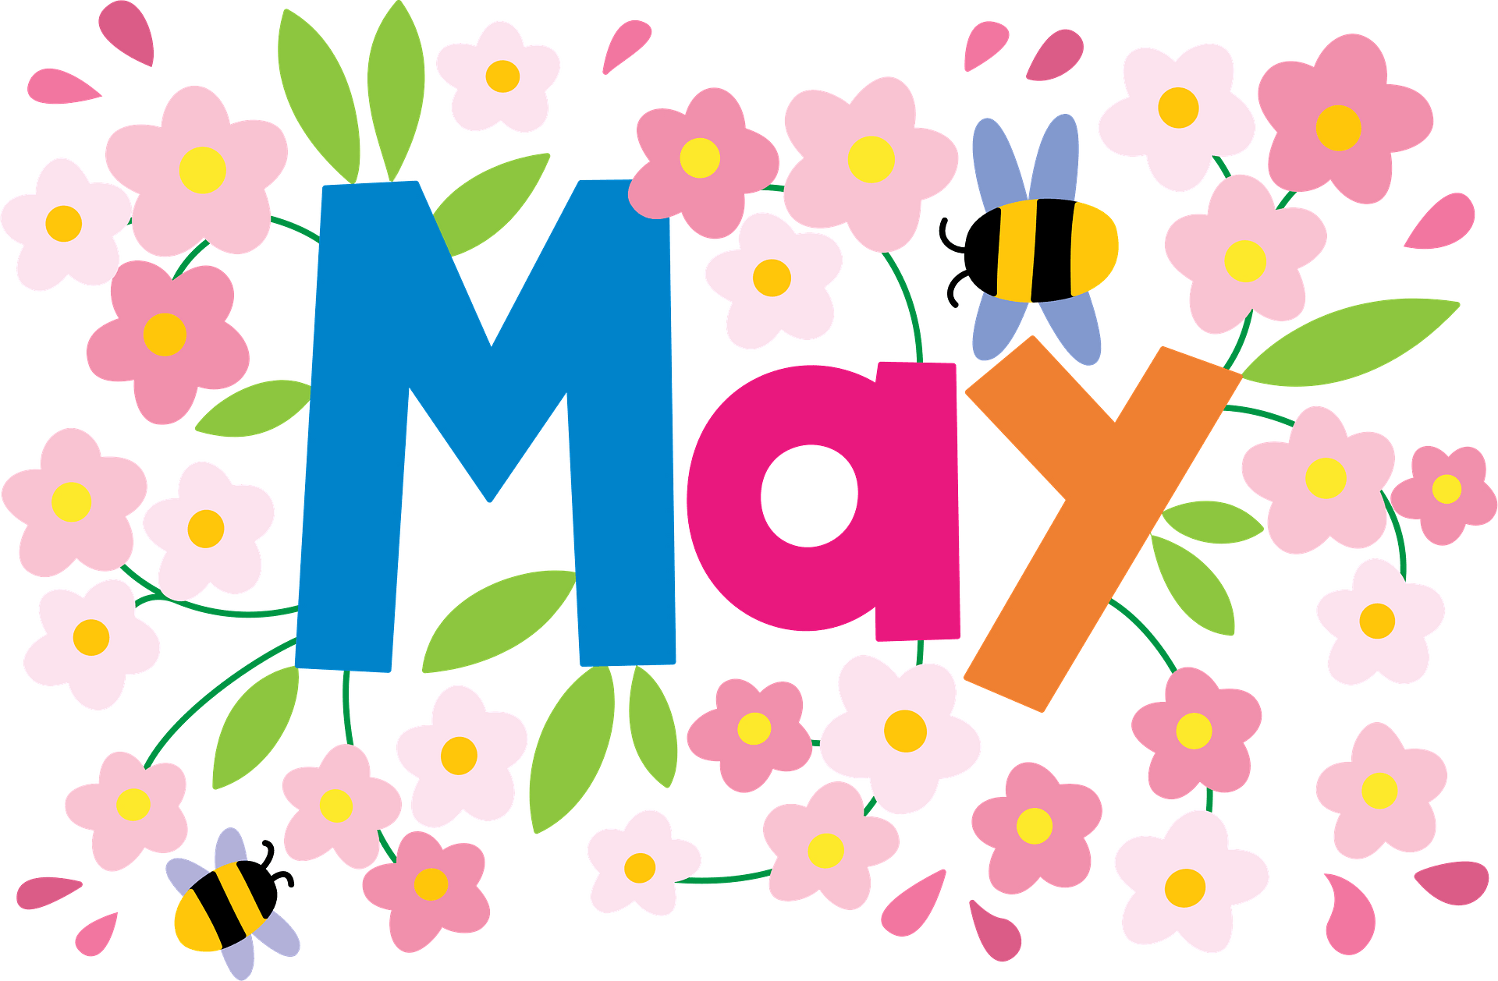

Team Member of the Month:  Ms. Yuliia  Beginner Lead Teacher |   Carrington Academy  Suwanee  3180 Peachtree Parkway  Suwanee, GA 30024 | Family of the Month:  The Chan Family  (Haley)

