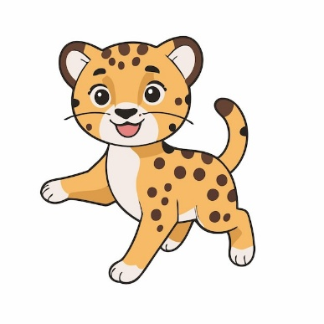


Monday | Tuesday | Wednesday | Thursday | Friday
  3.  First Day of 25-26  School Year    Happy Birthday  Ms. Mercedes! | 4. |   5.  Wear it Wednesday – Carrington Spirit Wear/Cheetah Print Day! | 6.    Family Appreciation  You are O’fish’ally the BEST |   7.  Football Fridays Begin! (Every Friday until the Superbowl)
10.  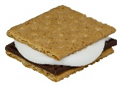  National S’mores  Day! |   11.  August Family Projects Go Home (Family Photo Collage) | 12    Wear it Wednesday – Wear All One Color Day! | 13    National Tell A Joke Day |   14    Cookie Friday and Football Friday!
  17  Please leave us a review! | 18    Chick Fil A Spirit Night  5-8pm | 19    Wear it Wednesday – Mismatch Day! | 20    National Lemonade Day! | 21  FAMLY GAME NIGHT    6-7 PM  This Photo by Unknown Author is licensed under CC BY-NC  Join us for pizza and board games!
24    National Waffle Day!  Chicken & Waffles for Lunch! | 25  National Banana  Split Day!    This Photo by Unknown Author is licensed under CC BY-NC-ND | 26    Wear it Wednesday - Hat Day! | 27    Principal Office Hours  12-1pm | 28    Cookie Friday and Football Friday!
31    August Family Projects DUE |  |  |  | 8/29  HAPPY BIRTHDAY  GENEVIEVE!!

Team Member of the Month:  Ms. Anjali |   Carrington Academy Suwanee  3180 Peachtree Pkwy  Suwanee, GA 30024 | Family of the Month:  The Niakan Family  Cora & Soren

